Task 2: Aggregate Revenue Reporting on Orders

Q1). Create an orders table with columns: order_id, restaurant_id, customer_name, total_amount, and order_date. Insert at least 12 orders distributed across at least 4 restaurants.
Query:-
create table orders (order_id int primary key auto_increment, restaurant_id int ,customer_name varchar(30),total_amount int,
order_date date);

insert into orders (restaurant_id,customer_name,total_amount,order_date) values
(1, 'Rahul', 1200.00, '2026-09-01'),
(1, 'Priya', 1500.00, '2026-09-02'),
(1, 'Amit', 1800.00, '2026-09-03'),
(2, 'Neha', 2000.00, '2026-09-04'),
(2, 'Karan', 1700.00, '2026-09-05'),
(2, 'Riya', 1600.00, '2026-09-06'),
(3, 'Vikas', 900.00, '2026-09-07'),
(3, 'Pooja', 1100.00, '2026-09-08'),
(3, 'Arjun', 1300.00, '2026-09-09'),
(4, 'Sneha', 2500.00, '2026-09-10'),
(4, 'Rohan', 1800.00, '2026-09-11'),
(4, 'Meera', 1200.00, '2026-09-12');
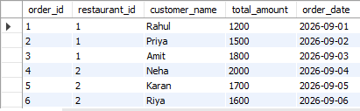
Q2). Write a query to show total revenue and average order value per restaurant.
Query:-

select restaurant_id ,sum(total_amount) as total_revenue,avg(total_amount) as average_order_value from order group by restaurant_id;
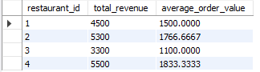

Q3). Write a query using HAVING to list only restaurants whose total revenue exceeds Rs 5,000
Query:-
select sum(total_amount) as total_revenue,restaurant_id from orders group by restaurant_id having sum(total_amount) > 5000;
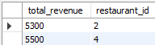
Q4). Write a query to retrieve the 5 most recent orders using ORDER BY and LIMIT.
Query:-
select customer_name,order_date orders from orders order by order_date desc limit 5;
